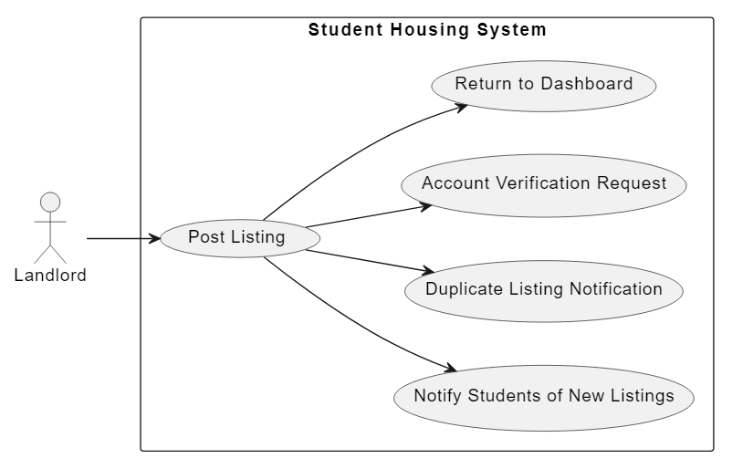Use Case Diagram

Use Case Number 1